SKILLSUSA NEBRASKA

Middle School Level
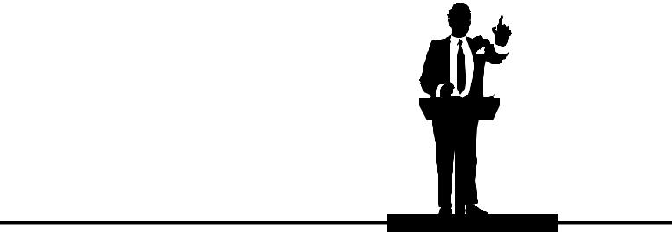

PREPARED SPEECH

Purpose

To evaluate each contestant’s ability to prepare and present clearly and effectively a series of thoughts relating to a central theme.

Observer Rule

Observers will be allowed to hear the speeches in the presentation room provided space is available. No talking or gesturing will be permitted. No member of the audience will be permitted to enter or leave the demonstration room while a contestant is speaking. No cameras, video recorders or tape recorders will be allowed by members of the audience.

Equipment and Materials
- Supplied by the contestant:
b. A single note card, if desired

Scope of the Contest

- Contestants should prepare for public speaking by developing the following competencies:

  - Make a formal introduction

  - Demonstrate good grooming in dress and personal hygiene

  - Understand and practice elements of informal conversation

  - Prepare a presentation on a given topic for a specific time

  - Demonstrate an effective and pleasing delivery style

  - Effectively use verbal illustrations and examples

  - Pronounce words in a clear and understandable manner

  - Demonstrate good platform deportment and personal confidence

  - Organize speech material in a logical and coherent manner

  - Effectively vary voice in pitch, tone, tempo and volume

- The topic for the prepared speech - See next column

- The speech shall be 4 to 6minutes in length. Penalty: Five points will be deducted for each 30 seconds or fraction thereof under five minutes or for each 30 seconds or fraction there of over six minutes.

- Time limit: Time will be started when the speech begins. The timer will signal the speaker at four minutes and at six minutes. The contestant will be permitted to use a watch or clock.

- A single note card will be permitted. The card should be no larger than 4”x6” so as not to detract from the effectiveness of the speech. No other visual aids or props will be permitted.

- Contestants will not mention or display their name, school, or city.

- Contestants will submit one computer generated copy of the speech, to the judges, prior to the contest.

Arrangement of Rooms

- No speaker’s stand (lectern/podium) will be used.

**Theme for Speech

18

SKILLSUSA CHAMPIONSHIPS

PREPARED SPEECH (MIDDLE LEVEL) RATING SHEET

CONTESTANT # ______________ |  |  | Middle school ❏ | Semifinals | ❏
ROOM # ____________________ |  |  |  | Finals | ❏
DATE _______ / _______ / ___
ITEMS EVALUATED | POSSIBLE | SCORE | COMMENTS
 | POINTS
Opening | 10
Appearance
 | 5
Introduction
Voice
(pitch, tempo, | 10
volume, enthusiasm)
Platform
Deportment | 10
(gestures, poise, eye
contact, mannerisms)
Organization
(logic, clarity, | 20
suitability,
conference)
Mechanics
(diction, grammar, | 10
pronunciation, word
picture)
Closing
(summary, | 15
conclusion)
Effectiveness
(assigned topic
covered, purpose, | 20
impress, inform,
persuade)
SUBTOTAL | 100
TIME PENALTY
(Minus 5 points for
each fraction of 30
seconds under 4
minutes or over 6
minutes)
TOTAL POINTS

19

