TEAM ENGINEERING CHALLENGE

Middle School

PURPOSE

This contest is designed to evaluate and to recognize outstanding students for excellence and professionalism in the areas of creative and critical thinking skills and the decision making process, to solve a problem. The contest is intended to foster creativity, innovation, team work, and problem solving skills.

GENERAL REGULATIONS

CLOTHING REQUIREMENT
For men: Official blazer, jacket or sweater; black dress slacks; white dress shirt; plain black tie with no pattern or SkillsUSA black tie; black socks and black shoes.

For women: Official blazer or jacket; black dress skirt (knee-length) or slacks with business like white, collarless blouse or white blouse with small, plain collar that may not extend onto the lapels of the blazer; black sheer or skin-tone seamless hose and black dress shoes.

These regulations refer to clothing items that are pictured and described at: www.skillsusastore.org. If you have questions about clothing or other logo items, call 800-401-1560 or 703-956-3723.

Note: Contestants must wear their official contest clothing to the contest orientation meeting.

ELIGIBILITY

This contest is open to active SkillsUSA members enrolled in a middle school chapter (grades 6-8). A team consists of 3 students from the same local chapter.

Teams must qualify from their local state conference.

OBSERVER RULE

Observers will be allowed to watch the match providing space is available. No talking or gesturing will be permitted. The event chair or moderator may remove observers and/or close the event to observers for cause.

EQUIPMENT AND MATERIALS

- Supplied by the technical committee:

  - All tools, materials, and supplies necessary to solve the contest problem except those items listed under number two below
i. Such items may include: hack saw, glue guns, cordless drill.

  - All necessary information and furnishings for judges and technical committee

- Supplied by the students:

a. Drawing equipment (team’s choice - for example: ruler, straightedge, t-
square, triangle, scale, pencils, pens, compass, etc )
- Safety glasses

- Calculator

- Scissors

- Exacto-knife or equivalent

- Coloring / Writing utinsels ( Markers, Crayons, Colored Pencils, etc)

  - Paint is not allowed.

- Students are not allowed materials that will “add” to their prototype.

  - Tape, glue, paper, staples, paper clips, etc

- Other tools as listed on the contest update page of the national website

CONTEST PROCEDURES

- Contestants will be identified by number only.

- The Team Written Test will be taken during the pre-contest briefing.

- The technical committee will provide each team with the problem and the contest supplies at the time of the pre-contest briefing.
- Each team’s “solution” will be constructed on site.

  - Construction is ONLY allowed in the contest area and during the contest times as presented in the pre-contest briefing.
- Contest judges will interview each team as a part of the contest.

  - Team interview timeslots will be available during the pre-contest briefing.

SCOPE OF THE CONTEST

Knowledge Performance

- The contest includes a written test to be taken by all members of the team at the same time.

.

Skill Performance

- The demonstration is a presentation of an occupational skill accompanied by a clear explanation of the topic through the use of examples, experiments, displays and practical testing operations.

Contest Guidelines

The Team Engineering Challenge contest will allow SkillsUSA members to demonstrate their ability to work together to solve a problem.

- The challenge will be selected from an area such as, but not limited to:

  - Transportation

  - Communications

  - Construction

  - Manufacturing

  - Biotechnology

  - Engineering

- The contestant’s advisor/instructor must attend the mandatory orientation meeting with the contestant.

- Contestants will not take the skills-related written or Professional Development

Test as outlined in the general regulations.

- Tie Breaker — Tie will be broken by reviewing the Highest score from the team rubrics. If tie is not broken from option a, then option b and c will be looked at in order.
  - “Solution: Performance”

  - “Interview: Problem Solving / Team Work”

  - “Written Test score”

STANDARDS & COMPETENCIES

TEC 1.0 — Perform effectively as team members

- Demonstrate group problem-solving techniques
- Demonstrate team proficiency in construction of a building project

- Perform additional teamwork competencies as determined by the technical committee

TEC 2.0 — Wear appropriate clothing for the national contest

- Display clothing that meets national standards for competition

- Demonstrate good grooming in dress and personal hygiene

TEC 3.0 – Integrate knowledge of basic engineering principles into technical writing and presentations following the guidelines the contest technical committee has established

3.1 Apply engineering knowledge in the areas of force, work, rate, resistance, energy, power, force transformers, momentum, waves and vibrations, energy converters, transducers, radiation, optical systems

TEC 4.0 — Transform existing systems into conceptual models

- Transform conceptual models into determinable models
- Use determinable models to obtain system specifications

- Select optimum specifications and create physical models

4.4. Apply the results from physical models to create real target systems
- Critically review real target systems and personal performance
- Design effective and usable IT-based solutions and integrate them into the user environment
- Assist in the creation of an effective project plan

- Identify and evaluate current and emerging technologies and assess their applicability to address the users’ needs

TEC 5.0 — Showcase knowledge of project planning

- Apply brainstorming techniques

- Implement benchmarking

- Discuss continuous improvement

- Explain cause and effect relationships

- Apply knowledge of customer satisfaction

- Demonstrate how to collect data

- Apply decision-making skills

- Define and describe a process

- Empower team members

- Recognize methods of idea generation

- Prioritize tasks

- Reach consensus amongst the team

- Display teamwork during the contest 5.13.1 Have equal team participation

5.13.2 Show positive group dynamics 5.13.3 Define team roles

Committee Identified Academic Skills

The technical committee has identified that the following academic skills are embedded in this contest.

Math Skills

None Identified

Science Skills

None Identified

Language Arts Skills

- Provide information in oral presentations
- Demonstrate use of verbal communication skills: choice, pitch, feeling, tone and voice

- Demonstrate use of nonverbal communication skills: eye contact, posture and gestures using interviewing techniques to gain information
- Identify words and phrases that signal an author’s organizational pattern to aid comprehension
- Organize and synthesize information for use in written and oral presentations

- Demonstrate knowledge of appropriate reference materials

- Demonstrate understanding of skill

Connections to National Standards

State-level academic curriculum specialists identified the following connections to national academic standards.

Math Standards

None Identified

Source: NCTM Principles and Standards for School Mathematics. To view high school standards, visit: standards.nctm.org/document/chapter7/index.htm. Select “Standards” from menu.

Science Standards

None Identified

Source: McREL compendium of national science standards. To view and search the compendium, visit: www.mcrel.org/standards-benchmarks.

Language Arts Standards

- Students adjust their use of spoken, written and visual language (e.g., conventions, style, vocabulary) to communicate effectively with a variety of audiences and for different purposes

- Students employ a wide range of strategies as they write and use different writing process elements appropriately to communicate with different audiences for a variety of purposes

- Students use spoken, written and visual language to accomplish their own purposes

(e.g., for learning, enjoyment, persuasion and the exchange of information)

Source: IRA/NCTE Standards for the English Language Arts. To view the standards, visit: www.ncte.org/standards.

SKILLSUSA CHAMPIONSHIPS | Team #:
Team Engineering Challenge Rating Sheet | ______
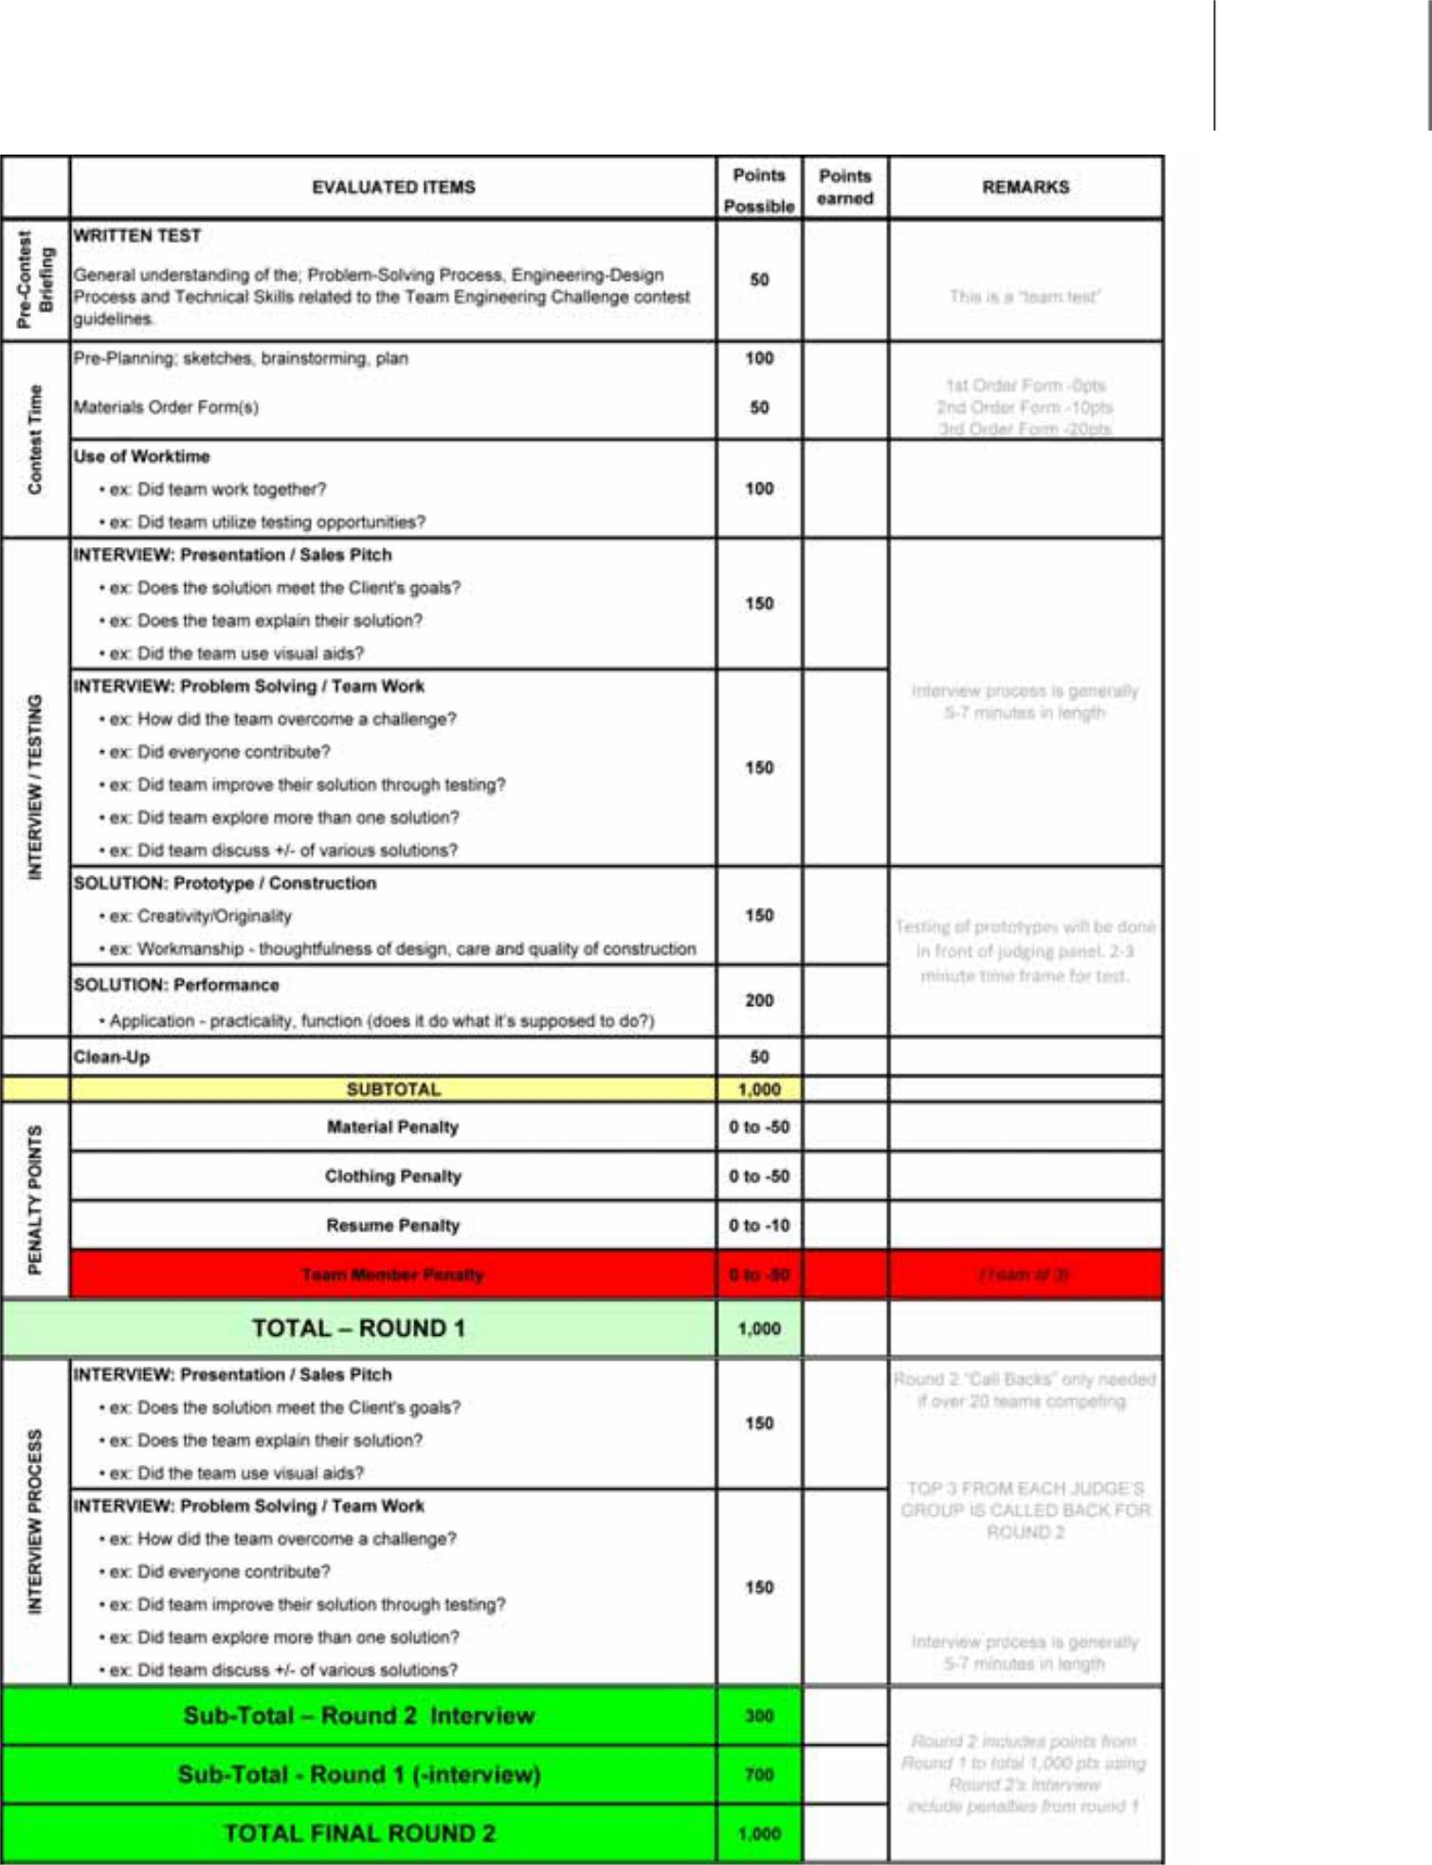

Final Rank:

