
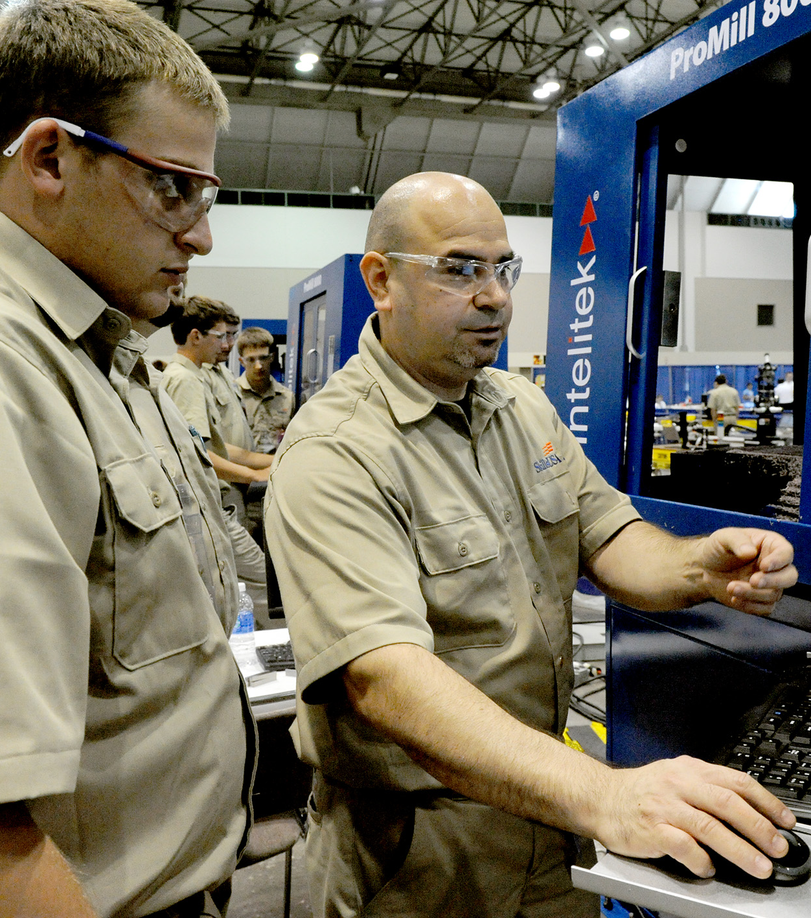
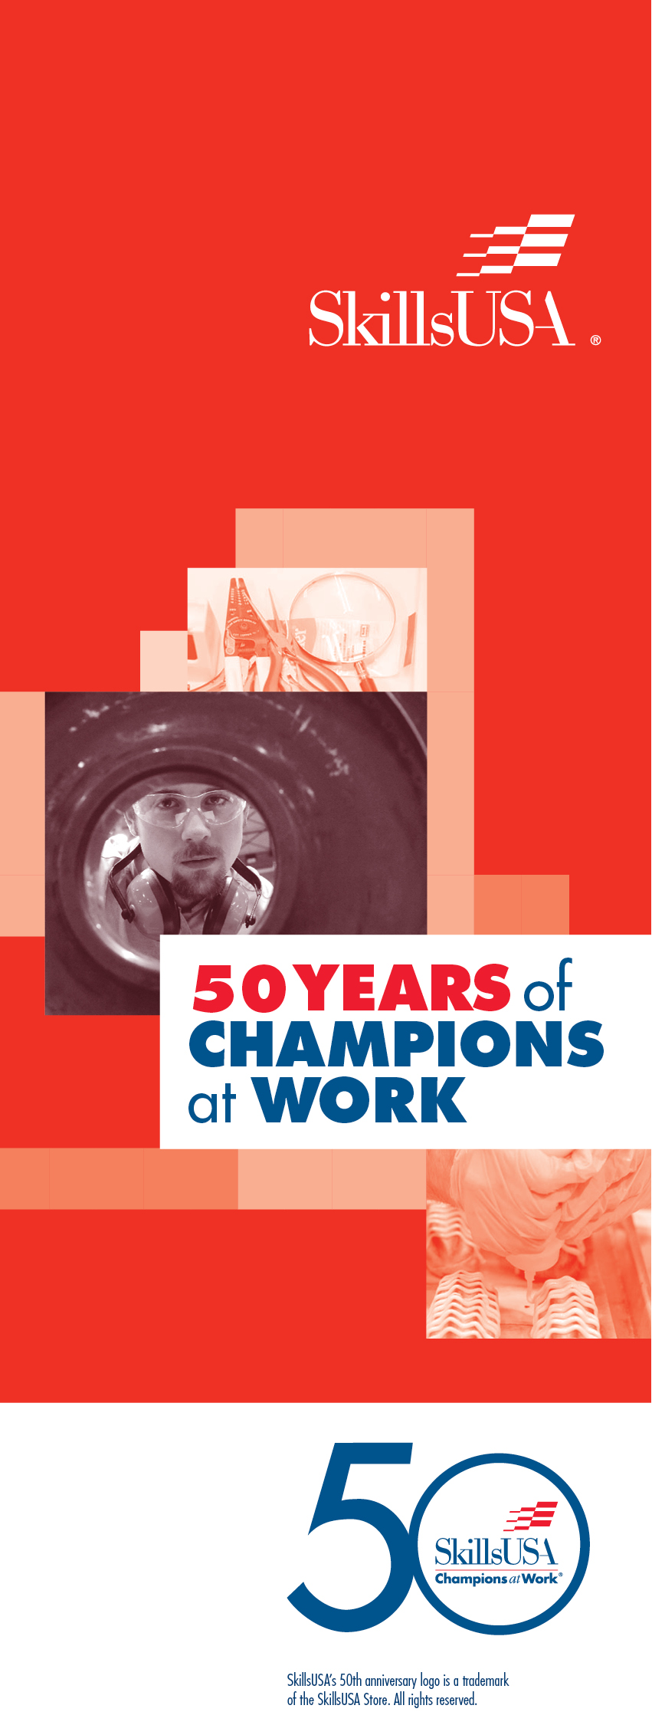
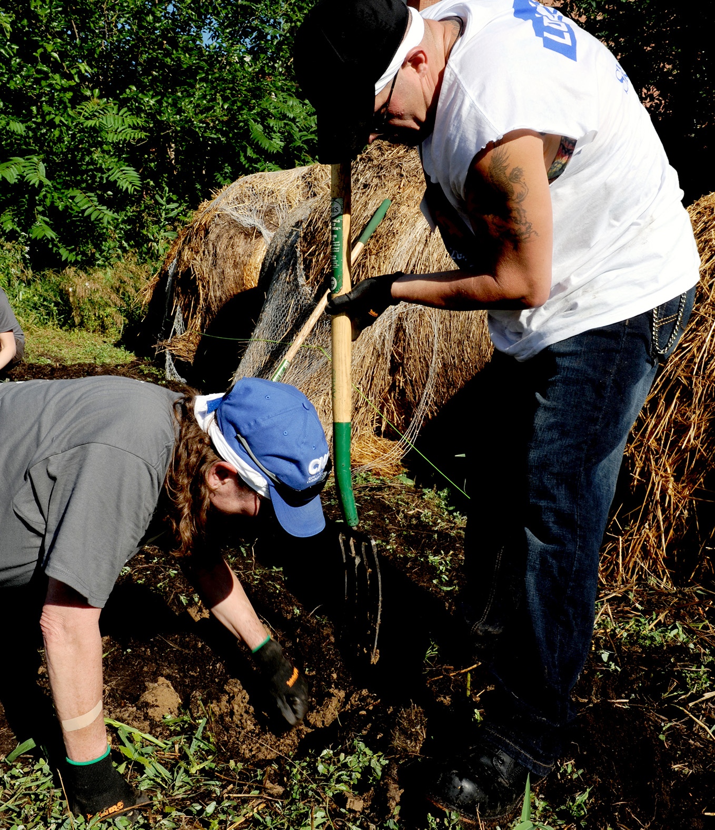
Service to Others
There is nothing more fulfilling than helping others. That is why service is one of SkillsUSA’s top priorities. You can truly make a difference on your campus or in the community by applying your knowledge and skills through service. The best part is, coming up with a service project is easy and rewarding. Together with other SkillsUSA members, you can share your time and energy to make a lasting difference in your corner of the world.

Travel
Want to see new places and meet new people? SkillsUSA can put you on the road to a variety of destinations depending on your level of involvement. Competitions and leadership conferences can lead to local, state, national and even global travel. Not only is this exciting from a student perspective, it also prepares you for potential careers that require mobility and exposure to different types of people and cultures. If you’re ready to broaden your horizons, SkillsUSA is ready to take you there!

Teamwork
Effective teams are fundamental to the success of any organization. Employers seek individuals who effectively work together to accomplish a common goal. SkillsUSA is just the place to learn the fundamentals of teamwork including trust, flexibility, loyalty and conflict resolution. Join a SkillsUSA team and gain valuable experience while building new friendships!
Fun Experiences
Like the idiom “Life is what you make of it,” SkillsUSA is about making the most of your membership experience. Some of the most fun experiences are learning new things, meeting new people and seeing new places. And, you are the one in charge. Whether it’s attending social activities, participating in competitions, volunteering for a community service project or providing leadership as an officer, you are the master of your SkillsUSA adventure. Don’t let this opportunity for fun, learning and career development pass you by. SkillsUSA awaits! Seize the day!

SkillsUSA
[Street Address]
[City], [State] [ZIP]
[Web Address]

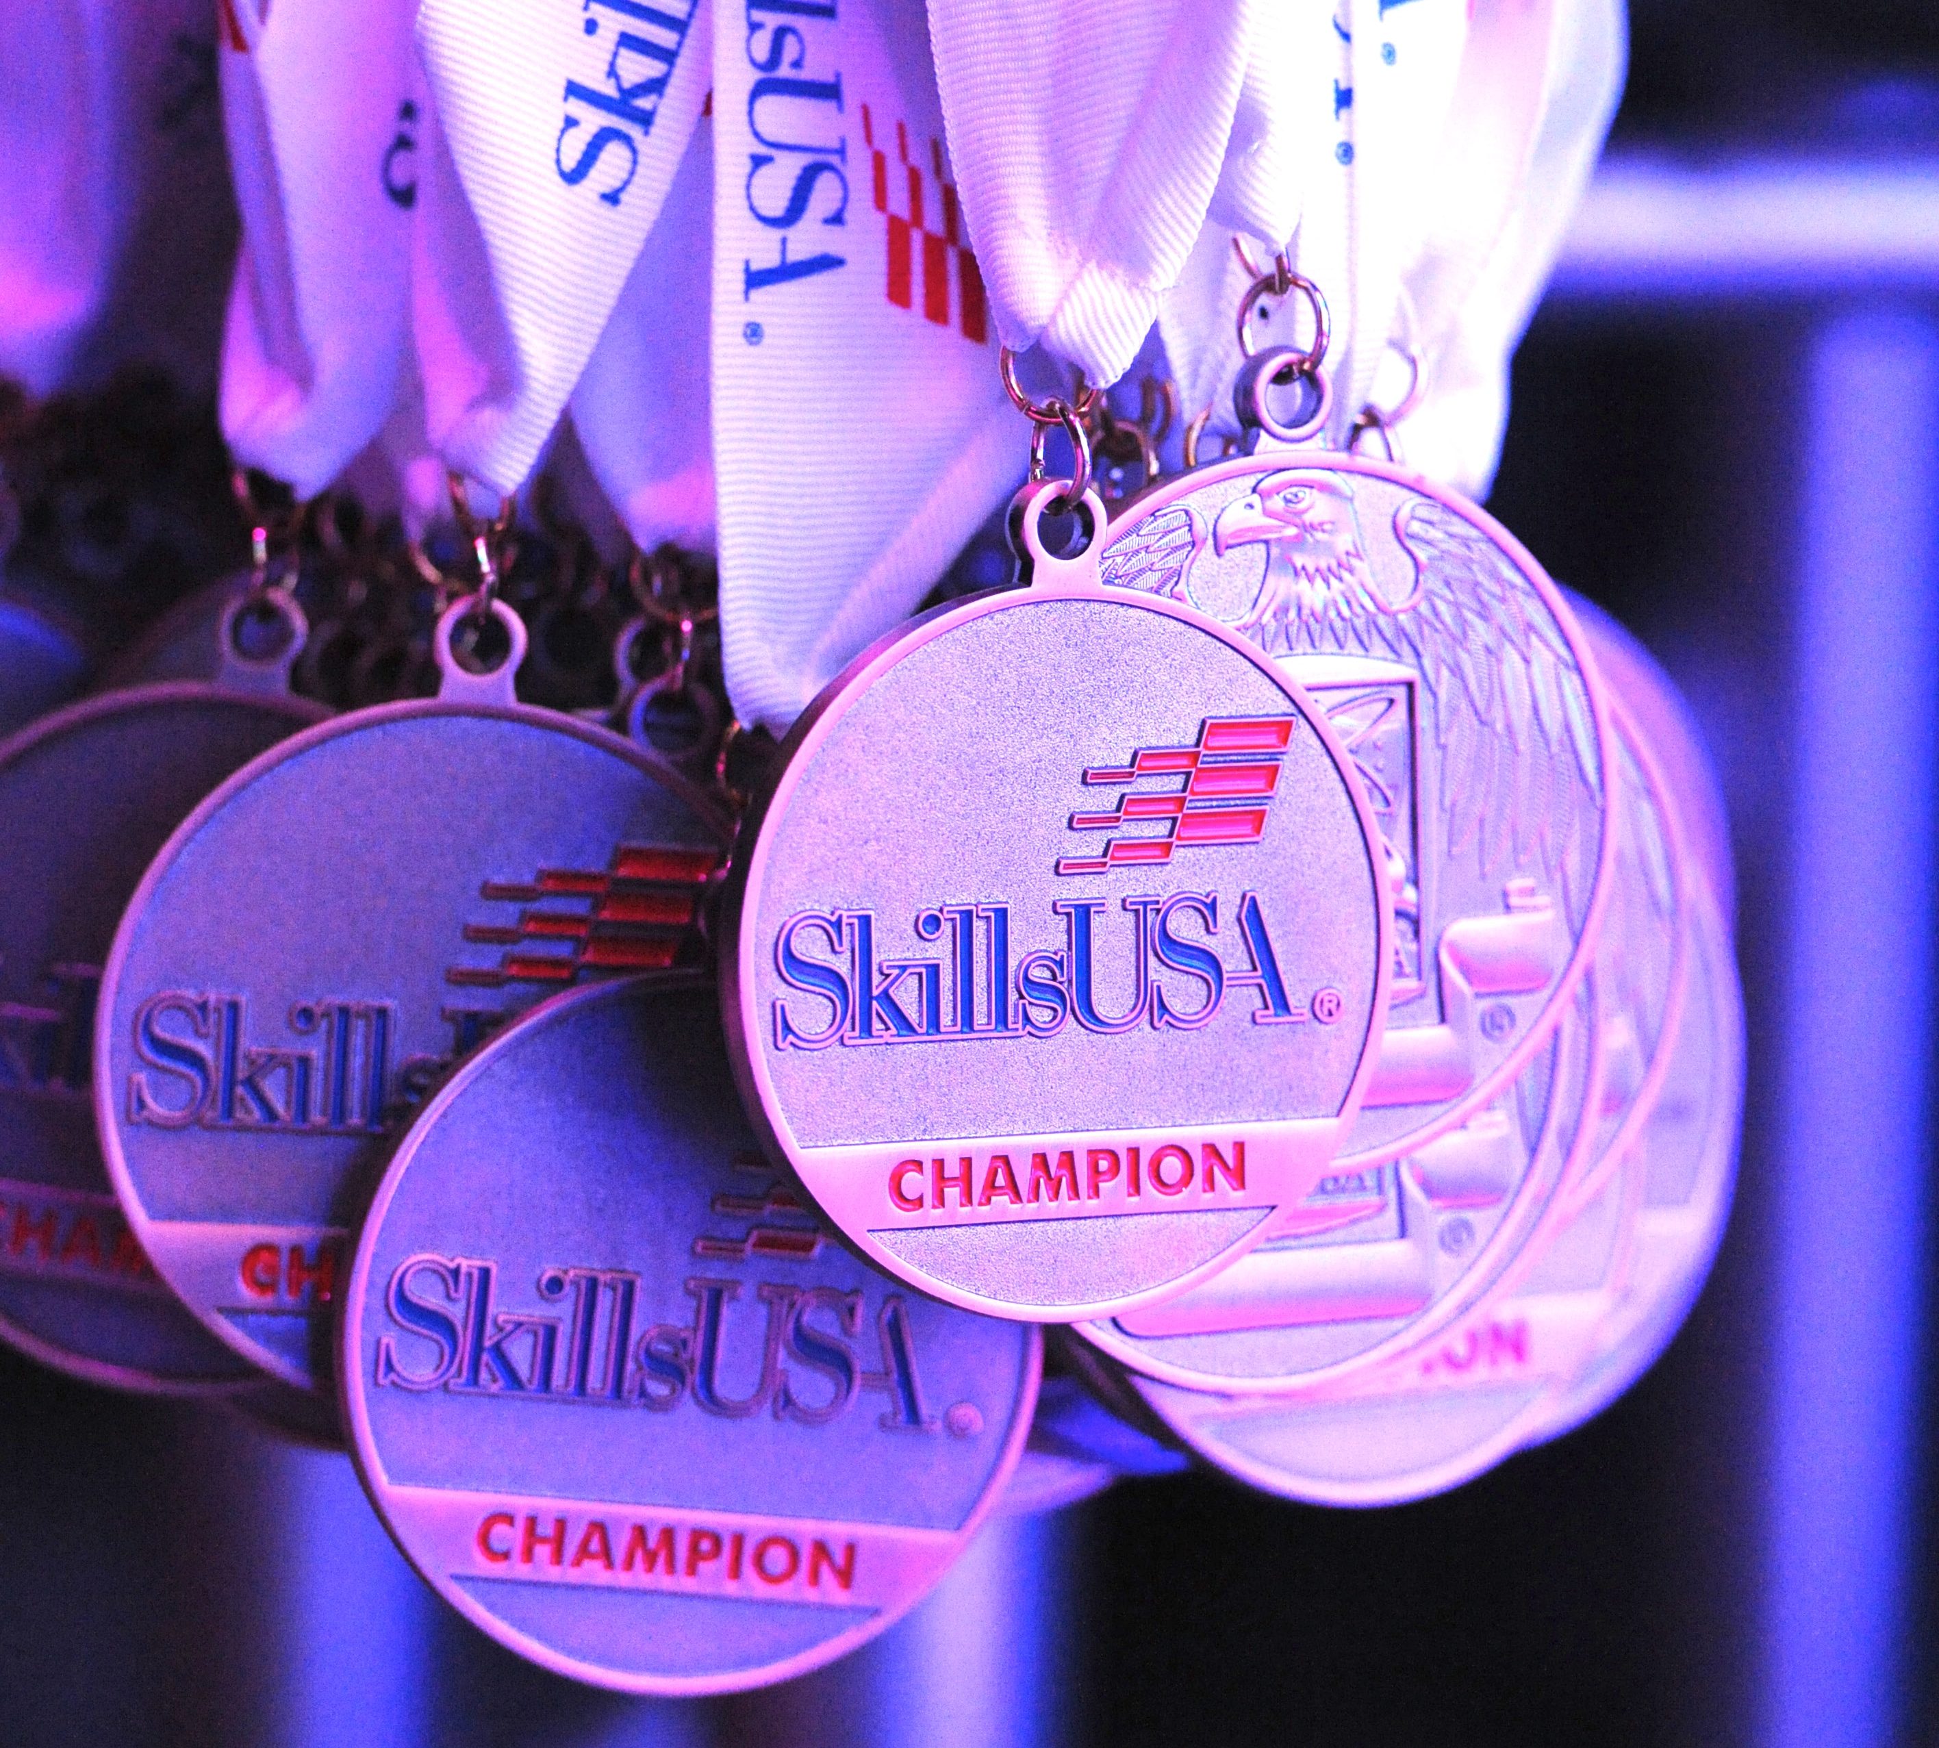
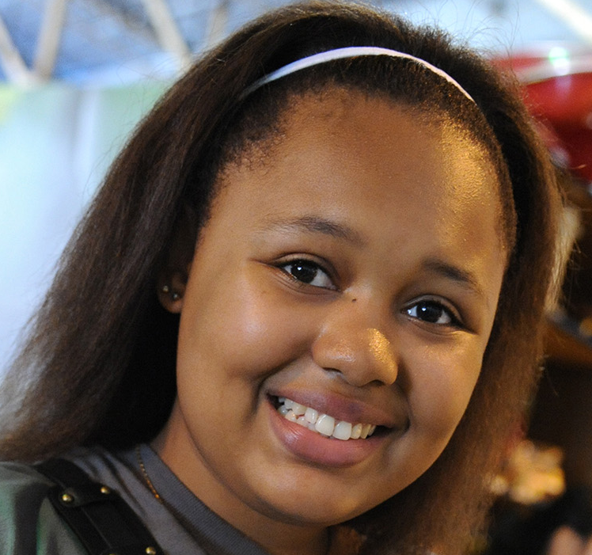
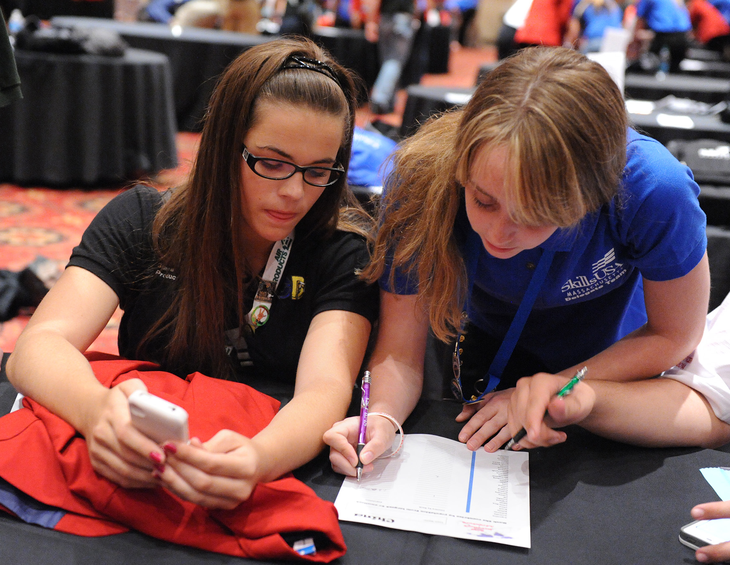

Why Join?
Advantages of membership include:
- Teamwork and leadership development
- Access to scholarships
- Reinforcement of employability skills
- Nationally recognized contest program
- Community service opportunities
- Networking with potential employers

Leadership
Leadership is influence! There is no better way to build leadership skills than to help others improve. Through SkillsUSA you can plan and implement a community service project, run for chapter office or compete in leadership development events. All of these experiences develop valuable leadership skills such as communication, decision making, group collaboration and problem solving.

Scholarships
Pursuing higher education is costly. Whether you’re attending a technical school, community college or university, expenses such as tuition, books and living expenses add up quickly. SkillsUSA members are eligible for more than
$1 million total in scholarships annually at the state and national level. In some cases, there are local scholarships as well. Give yourself an opportunity to get ahead by taking advantage of the generous support available only to SkillsUSA member.

Competition
Do you like to compete for prizes, scholarships and awards? SkillsUSA offers countless opportunities to showcase skills in competitive events while earning recognition that looks great on a résumé. You can compete at the local, regional, state and national levels in areas applicable to your career choice. Not only will this help you learn to work under pressure, but it will also give you a competitive edge in the workplace. You’ll also have an opportunity to meet and learn from industry professionals.

SkillsUSA: 50 Years of Champions at Work
SkillsUSA is a dynamic and career-oriented leadership organization focused on individual success at home, the classroom, the community and the workplace. Involvement in SkillsUSA can change your life. For the majority of students, SkillsUSA is their first professional organization. The experiences and knowledge gained provide an excellent platform for career development and success.

