OPENING AND

CLOSING CEREMONIES

PURPOSE

To evaluate the contestants’ understanding of the symbolic representation of the colors and assembled parts of the SkillsUSA emblem and to evaluate teamwork and professional presentation skills.

First, refer to General Regulations, Page 9.

CLOTHING REQUIREMENT

For men: Official blazer, jacket or sweater; black dress slacks; white dress shirt; plain black tie with no pattern or SkillsUSA black tie; black socks and black shoes.

For women: Official blazer or jacket; black dress skirt (knee-length) or slacks with businesslike white, collarless blouse or white blouse with small, plain collar that may not extend onto the lapels of the blazer; black sheer or skin-tone seamless hose and black dress shoes.

These regulations refer to clothing items that are pictured and described at: www.skillsusastore.org. If you have questions about clothing or other logo items, call 800-401-1560 or 703-956-3723.

Note: Contestants must wear their official contest clothing to the contest orientation meeting.

ELIGIBILITY

Open to a team of seven active SkillsUSA members. The team need not be comprised of officers, and team members may be from more than one section, but team members must be organized under one local charter and active members in the same division.

OBSERVER RULE

Observers will be allowed to view the demonstration provided space is available. No talking or gesturing will be permitted. No

member of the audience is to leave or enter the

demonstration room while a team is competing.

EQUIPMENT AND MATERIALS

- Supplied by the technical committee:

  - Official SkillsUSA emblem

  - Easel for emblem

  - U.S. flag

  - Gavel and sound block

  - Speaker’s stand (lectern)

  - Two draped tables 8 feet long and 30 inches wide

  - Six chairs

  - Copy of SkillsUSA Championships Technical Standards for each judge

  - All necessary information and furnishings for judges and technical committee
- Supplied by the contestant:

  - All competitors must create a one-page résumé and submit a hard copy to the technical committee chair at orientation. Failure to do so will result in a 10-point penalty.

Note: Your contest may also require a hard copy of your résumé as part of the actual contest. Check the Contest Guidelines and/or the updates page on the SkillsUSA website: www.skillsusa.org/compete/ updates.shtml

ARRANGEMENT

OF DEMONSTRATION ROOM

The room provided will be arranged to seat an audience and will have a demonstration area at the front of the room. The room will be set up by the technical committee according to the diagram (see full diagram at end of contest) as closely as possible, based upon the confines of the facility. The tables will be placed 6 feet to 8 feet from the wall depending on what the facility permits. The chairs may be placed anywhere behind the tables. The room will contain a center aisle. If facilities permit, the room could have at least one side aisle added.

2015-2016 SkillsUSA Championships Technical Standards • 73

Scope of Contest

This is a teamwork and oral presentation contest that evaluates teams’ understanding of the symbolic representation of the colors and assembled parts of the SkillsUSA emblem. Each team includes seven registered members in the roles of president, vice president, parliamentarian, reporter, treasurer, secretary and historian.

Knowledge Performance

There is no written knowledge test (other than the SkillsUSA knowledge test, which will be used as a tie breaker) required for this contest. Knowledge of ceremonies will be assessed during the performance demonstration.

Skill Performance

The contest is a demonstration of the SkillsUSA Opening and Closing Ceremonies conducted according to the script and description as printed in the SkillsUSA Championships Technical Standards.

Contest Guidelines

- The official script and description for the contest shall be the one printed in the

SkillsUSA Championships Technical Standards. No other method of performing the ceremony will be allowed for the purpose of the contest demonstration.

- Teams will draw numbers during the pre-contest orientation meeting to determine the order of performance and demonstration times. Only the president, team captain or other representative of the team will attend the pre-contest meeting.

- Each team must consist of seven registered members in the roles of president, vice president, parliamentarian, reporter, treasurer, secretary and historian. Note: The team may perform with six members (with a 14-point deduction) in the event that a member fails to show up or is forced to withdraw within five days of the competition. Another officer, not the president, will be assigned the missing part.

- One member of the team, not the president, will deliver the thought for the day. It will be scored for voice, stage presence and mechanics.

- There is no time limit for the demonstration.

- The team will be allowed three minutes to properly assemble the contest paraphernalia before the demonstration begins. Any number of team members may enter the room to set up. Members will be asked to leave the room when three minutes are up. No additional points are given for the manner in which the team comes into or leaves the room.

- Only the official SkillsUSA emblem will be used.

- If notification is given to the contest chairperson at the contestant orientation meeting that one or more team members will not say the Pledge of Allegiance for religious reasons, no points will be deducted. However, if no one on a team says the pledge, 42 points will be deducted.

Evaluation Criterion

Evaluations will be made by visual observation at the performance. A scoring rubric will be used.

Official SkillsUSA Championships Opening

and Closing Ceremonies: Opening Ceremony

The officers will walk in from the outside entrance to their respective places and remain standing.

President: (Raps twice with gavel.) The meeting will come to order. The thought for the day will be given by the (designated officer).

Designated Officer: (Gives the thought for the day at the speaker’s stand and returns to his or her seat.)

President: (Raps gavel once to seat the officers.) The emblem is symbolic of the SkillsUSA organization. You are about to witness the emblem ceremony, in which the meaning of each component of our emblem will be given and the significance of the colors described. (Raps gavel once, calls for Mister or Madame Parliamentarian and steps directly back.)

Parliamentarian: (Picks up the shield and moves to speaker’s stand.) The shield represents patriotism. (Pauses.) The shield

74 • Sponsored by Goodheart-Willcox Publisher

denotes our belief in democracy, liberty and the American way of life. (Affixes the shield to the SkillsUSA emblem stand, calls for Mister or Madame Reporter and returns to seat.)

Reporter: (Picks up the gear and moves to the speaker’s stand.) The gear represents the industrial society. (Pauses.) The gear, symbolic of the industrial society, denotes the interdependence and cooperation of the individual working with labor and management for the betterment of mankind. (Affixes the gear to the emblem, calls for Mister or Madame Treasurer and returns to seat.)

Treasurer: (Picks up the torch and moves to speaker’s stand.) The torch represents knowledge. (Pauses.) The flaming torch reflects the light of knowledge, which dispels the darkness of ignorance. In the light of the torch, progress will be made toward the vocational goals of the individual. (Affixes the torch to the emblem, calls for Mister or Madame Secretary and returns to seat.)

Secretary: (Picks up the orbital circles and moves to speaker’s stand.) The orbital circles represent technology. (Pauses.) The circles represent the challenge of modern technology and the training needed to accept and master new technical frontiers and the need for continuous education. (Affixes the circles to the emblem, calls for Mister or Madame Vice President and returns to seat.)

Vice President: (Picks up the hands and moves to speaker’s stand.) The hands represent the individual. (Pauses.) The hands portray a search for knowledge and our desire to acquire a skill. In the process of attaining knowledge and skill, we will develop a respect for the dignity of work and become productive and responsible citizens. (Affixes the hands to emblem, calls for Mister or Madame Historian and returns to seat.)

Historian: (Moves to emblem and pauses.) With the affixing of the golden hands, we add the final official color of SkillsUSA. The colors of the emblem represent our organization. Red and white represent the individual states and the chapters; blue represents the common union of the states and the chapters; and gold represents the individual, the most important

element of SkillsUSA. (Calls for Mister or Madame President and returns to seat.)

President: (Picks up the letters ‘SkillsUSA” and moves to emblem and affixes the letters to emblem; pauses.) All of the components constitute our emblem. Separately, they could be applied to many organizations, but as one unit, they represent the fundamental principles and purposes of our organization. The emblem represents SkillsUSA. (Returns to speaker’s stand and pauses. Raps three times with gavel for all to stand.) We will respect the flag with the Pledge of Allegiance. (In unison, team members turn to flag and place their right hands over their hearts.)

In Unison: I pledge allegiance to the flag of the United States of America, and to the republic for which it stands, one nation under God, indivisible, with liberty and justice for all. (In unison, right hand is lowered to side and all turn to front.)

President: (Raps once with gavel for all to be seated.)

Official SkillsUSA Championship Opening

and Closing Ceremonies: Closing Ceremony

President: Mister or Madame Secretary, have you a record of any further business to come before the meeting at this time?

Secretary: (Rises.) I have none, Mister or Madame President. (Is seated.)

President: Does any member know of any new or unfinished business that should come before this meeting? (Pauses for response.) Since there is no further business to come before the meeting at this time, we will prepare to adjourn. Since the rule is the basic instrument of our work, it is particularly fitting that we select the Golden Rule, “Do unto others as you would have them do unto you,” to govern our lives. Let us speak our pledge. (Raps three times with the gavel for all to rise and leads in reciting the pledge.)

In Unison: Upon my honor, I pledge:

2015-2016 SkillsUSA Championships Technical Standards • 75

To prepare myself by diligent study and ardent practice to become a worker whose services will be recognized as honorable by my employer and fellow workers.

To base my expectations of reward upon the solid foundation of service.

To honor and respect my vocation in such a way as to bring repute to myself.

And further, to spare no effort in upholding the ideals of SkillsUSA.

President: I now declare this meeting adjourned until our next regular meeting or until a special meeting shall be called by your president. (Raps once with gavel.)

(All officers turn in unison and exit the room in a formal manner.)

Standards and Competencies

OCC 1.0 — Demonstrate proper room setup

- Assemble the contest paraphernalia properly

OCC 2.0 — Demonstrate teamwork and coordinated activities

- Enter/exit room in step

- Sit, stand and turn in unison

  - Respond in unison to gavel raps immediately

  - Sit, stand and turn together

  - Synchronize movements

  - Perform natural movements

  - The sounding of the gavel will be the only sound made to signal movement
- Handle emblem properly

  - Pick up the pieces in the same smooth manner

  - Keep emblem straight when being held

  - Move with the emblem

  - Put emblem on the easel in the same manner

- Conduct pledges

  - Place hand over the heart in unison in preparation for speaking the Pledge of Allegiance

- Keep hands at sides during SkillsUSA pledge

OCC 3.0 — Demonstrate professional presentation skills as in voice, stage presence and mechanics
- Vary pitch, tempo, volume and enthusiasm of voices

- Exhibit stage presence including poise, eye contact, confident appearance, attitude and natural movements

- Use good language mechanics such as diction, pronunciation and enunciation

- Speak words with feeling and understanding

OCC 4.0 — Demonstrate accuracy of presentation

- Recite the script exactly as written

  - Include exact wording with commas, pauses and periods used in the correct places

  - Recite all of both pledges in unison

- Conduct a chronological presentation

- Strike sounding block with gavel in all instances

OCC 5.0 — Exhibit personal grooming, uniformity of dress and neatness

- Wear clothing that fits well

- Press clothing prior to performance

- Wear the same style jacket as all members

- Wear same style shirt, dress slacks, black socks and black dress shoes for males

- Wear same style shirt, slacks or skirt, dress shoes and same color hose for females (refer to clothing requirements)

- Arrange hair back and out of eyes for all contestants

Committee Identified Academic Skills

The technical committee has identified that the following academic skills are embedded in this contest.

Math Skills

None Identified

Science Skills

None Identified

76 • Sponsored by Goodheart-Willcox Publisher

Language Arts Skills

- Provide information in oral presentations

- Demonstrate use of verbal communication skills, such as word choice, pitch, feeling, tone and voice

- Demonstrate use of nonverbal communication skills, such as eye contact, posture and gestures using interviewing techniques to gain information

- Identify words and phrases that signal an author’s organizational pattern to aid comprehension

Connections to National Standards

State-level academic curriculum specialists identified the following connections to national academic standards.

Math Standards

None Identified

Source: NCTM Principles and Standards for School Mathematics. To view high school standards, visit: standards.nctm.org/document/chapter7/index.htm. Select “Standards” from menu.

Science Standards

- Understands the scientific enterprise

Source: McREL compendium of national science standards. To view and search the compendium, visit: www.mcrel.org/standards-benchmarks.
Language Arts Standards

- Students adjust their use of spoken, written and visual language (e.g., conventions, style, vocabulary) to communicate

effectively with a variety of audiences and for different purposes

- Students use spoken, written and visual language to accomplish their own purposes (e.g., for learning, enjoyment, persuasion and the exchange of information)

Source: IRA/NCTE Standards for the English Language Arts. To view the standards, visit: www.ncte.org/standards.

2015-2016 SkillsUSA Championships Technical Standards • 77

Opening and Closing Ceremonies Room Diagram
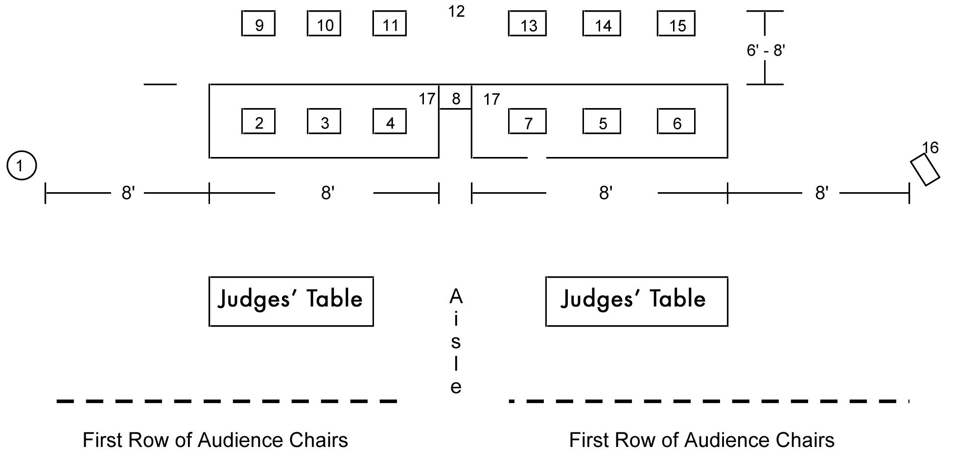

Diagram Key

1. American flag (8' from the front corner of the table)

Emblem Plastics (Nos. 2–7)

Note: Teams may decide the proximity of the plastics to each other. However, they must still be placed in the specified order from the podium and may not overlap.

- Shield

- Gear

- Torch

- Orbital circles

- Hands

- Letters

- Podium (speaker’s stand)

Chairs (Nos. 9–15)

Note: Teams may place the chairs any distance from the tables within the provided 6 feet to 8 feet space. For example, if the provided space is 7 feet, the chairs may be placed 1 foot, 2 feet, etc. from the table up to the point where the back of the chair is 7 feet from the table.

- Parliamentarian

- Reporter

- Treasurer

- President (no chair)

- Secretary

- Vice president

- Historian

- SkillsUSA emblem stand (easel — 8' from the front corner of the table)

- Gavel and sound block (wooden block — either side is acceptable)

78 • Sponsored by Goodheart-Willcox Publisher

